Festive Menu

Chicken Liver Pate, Tomato Chutney & Toasted Brioche GF*
Roasted Winter Vegetable Soup GF, VE
Goat’s Cheese Mousse with Pickled Beetroot, Roasted Apples and a Sweet Celery Dressing V, GF
OoOoO
Roasted Turkey, Sage & Onion Stuffing, Pigs in Blankets, Roasted Potatoes, Glazed Vegetables and Traditional Gravy GF*
Fillet of Sea Bream, Smoked Cauliflower Puree with Samphire and Roasted Sprouts Finished with a Watercress Dressing GF
Roasted Mediterranean Vegetables in a rich Tomato and Basil Reduction with Orzo Pasta V, GF, VE
OoOoO
Traditional Christmas Pudding with Honey Roasted Plums, Brandy Cream GF*
Chocolate & Orange Cheesecake with a Chocolate Crisp
Spiced Rum Caramelised Pineapple & Banana with a Coconut Ice Cream GF, V, VE
OoOoO
Freshly Brewed Tea or Coffee with Mini Mince Fancies

V - Vegetarian GF* - Can be Gluten-Free GF - Gluten Free
DF - Dairy Free DF* - Can be Dairy Free VE - Vegan

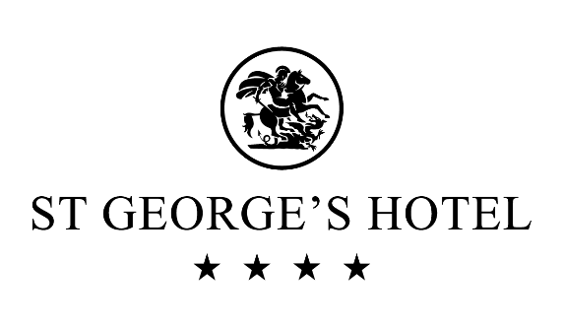

Festive Lunches through December
Have a party with your friends, colleagues or family and enjoy a fabulous Festive Lunch.
Served throughout December in the Terrace Lounge.
2 Courses £19
3 Courses £23

Dietary Requirements
Should you have any concerns about food allergies or intolerances please speak to a member of staff before you order your food or drink. Information on all allergen content is available on request.
facebook.com/stgeorgeshotelwales
twitter.com/stgeorgeshotel
pinterest.com/stgeorgeshotel/
facebook.com/stgeorgeshotelwales
twitter.com/stgeorgeshotel
pinterest.com/stgeorgeshotel/
facebook.com/stgeorgeshotelwales
twitter.com/stgeorgeshotel
pinterest.com/stgeorgeshotel/
facebook.com/stgeorgeshotelwales
twitter.com/stgeorgeshotel
pinterest.com/stgeorgeshotel/

